Experiment No 5

Title:
RESTful API Integration in the GrocerySpot App

Objective:
To learn data handling using APIs and integrate external data sources into the mobile application.

Theory:

Make your own API to Connect your mobile app:
Integrating an API containing information about grocery products, their descriptions, and prices into the GrocerySpot app is a crucial step in enhancing its functionality and providing users with valuable shopping insights. The process involves creating and deploying a custom API that exposes endpoints for fetching product data. This API can be developed using frameworks like Flask or Django for Python, which provide tools for building robust web APIs. Once the API is set up, the GrocerySpot app can send HTTP requests to the API endpoints to retrieve product information.

The API payload may include details such as product names, descriptions, prices, and availability. By structuring the API payload effectively, the app can efficiently parse and utilize the received data to populate its user interface with relevant grocery product listings.
Api payload:-
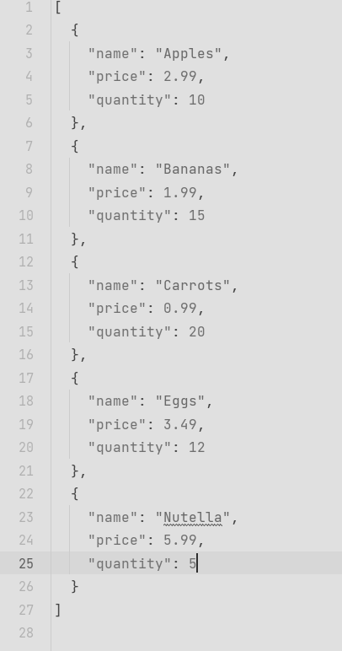

Making Api call inside:
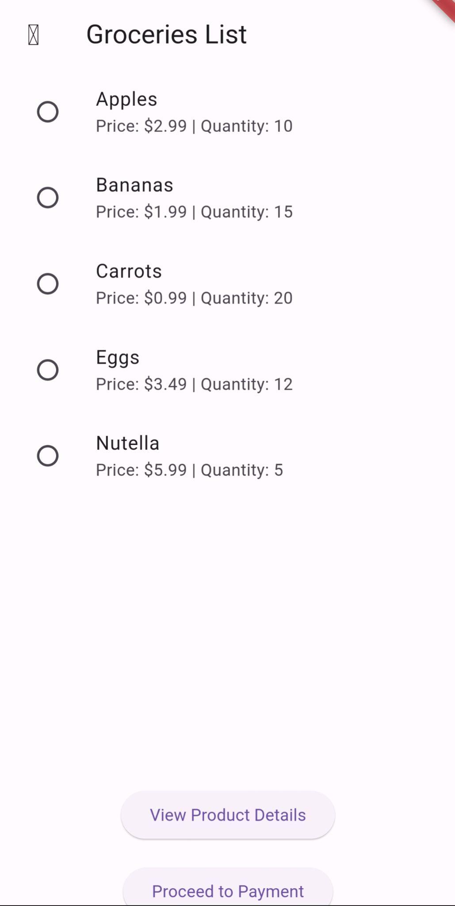

Connect the mobile app to an external API:
Integrating an external API, such as a grocery data provider or supplier, into the GrocerySpot app expands its functionality and enriches the user experience with access to a wider range of products and information. By establishing communication with the external API endpoint via HTTP requests, the app can fetch data about grocery products, including names, descriptions, prices, and availability.

Once the data is retrieved from the external API, it is parsed and processed within the app to extract the relevant information needed for display. This process involves converting the received JSON data into Dart objects using Flutter's built-in JSON decoding capabilities or third-party libraries.
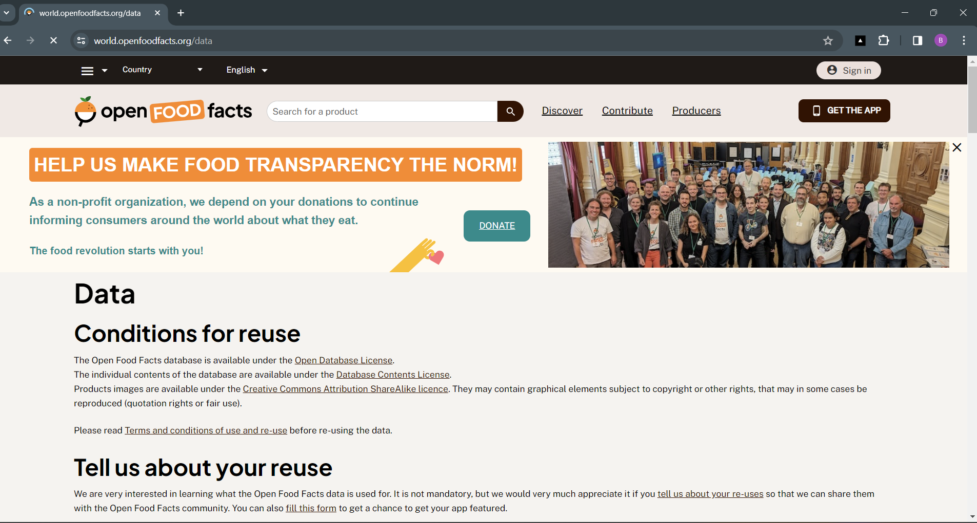

Retrieve data from the API and display it in your app:
With the parsed data from the API, the GrocerySpot app designs and implements screens to present this information to the user in a clear and organized manner. Using Flutter's rich set of UI widgets, such as ListView, Card, Text, and Image, the app dynamically populates its screens with grocery product listings retrieved from the API. The user interface may include features such as search functionality, sorting options, and filters to enhance the browsing experience for users.
On Click Nutella 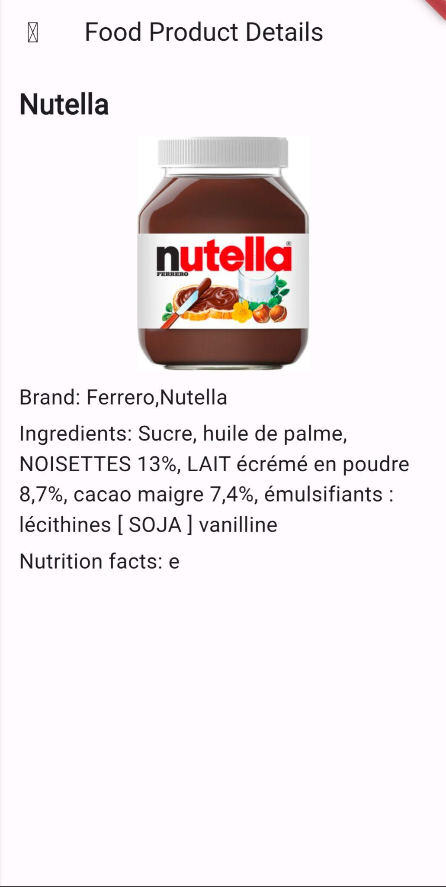

Implementing basic error handling and data validation:
To ensure a smooth and reliable user experience, the GrocerySpot app implements basic error handling and data validation mechanisms for interactions with the API. This includes handling errors such as network timeouts, server errors, and invalid responses from the API. Additionally, the app performs data validation to verify the integrity and consistency of the received data, preventing errors and inconsistencies in the user interface.
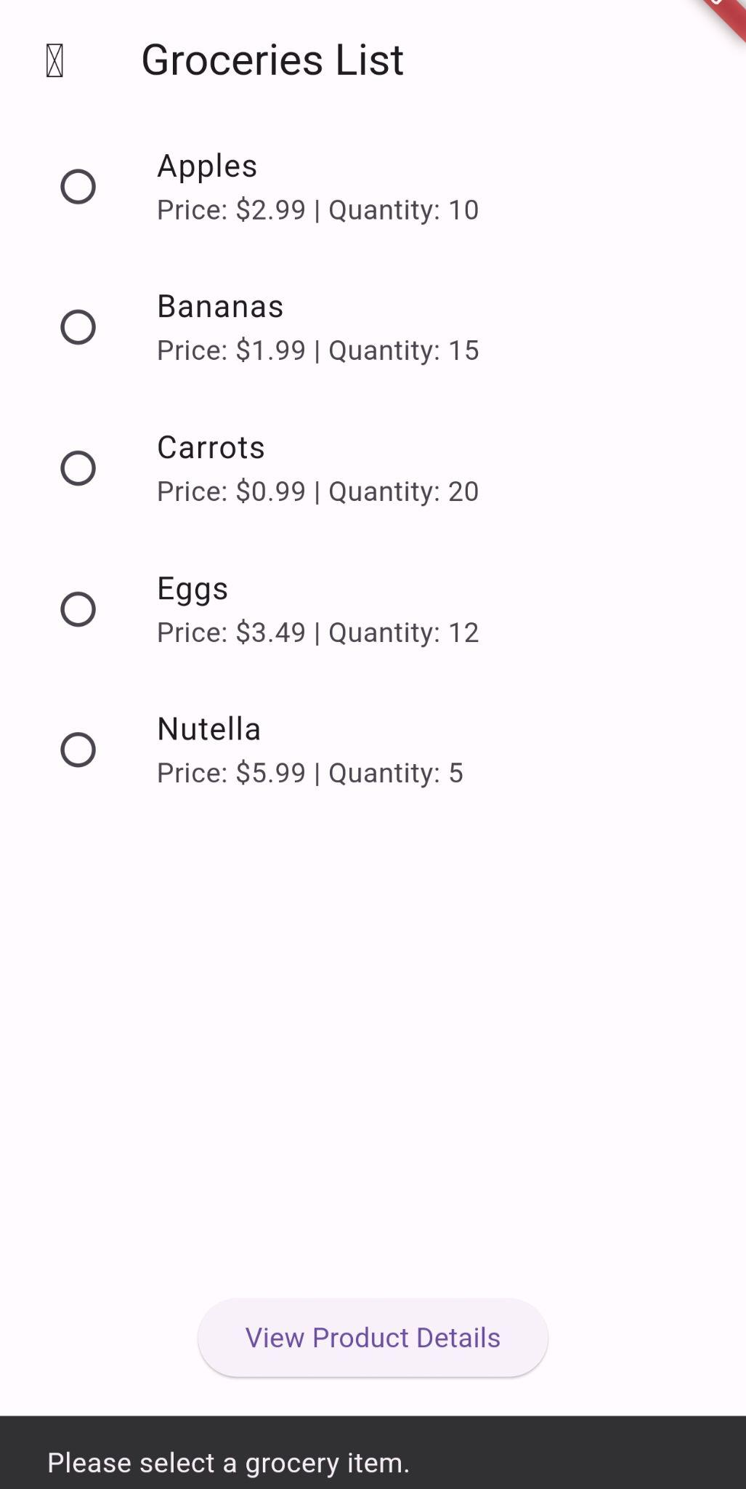 Shows an error when no item selected

Conclusion:
By integrating both a custom API and an external API into the GrocerySpot app, we have expanded its capabilities and enriched the user experience with access to real-time grocery product data. Connecting the app to external data sources opens up possibilities for providing users with valuable shopping insights and a wider range of product options. Through effective API integration, error handling, and data validation, the GrocerySpot app delivers a seamless and reliable shopping experience for users.

